ASSIGNMENT 4

Logan Quandt

2021-01-21

# Markdown Basics

## Favorite Foods

1. Steak
2. Cheeseburger
3. Eggs

## Images

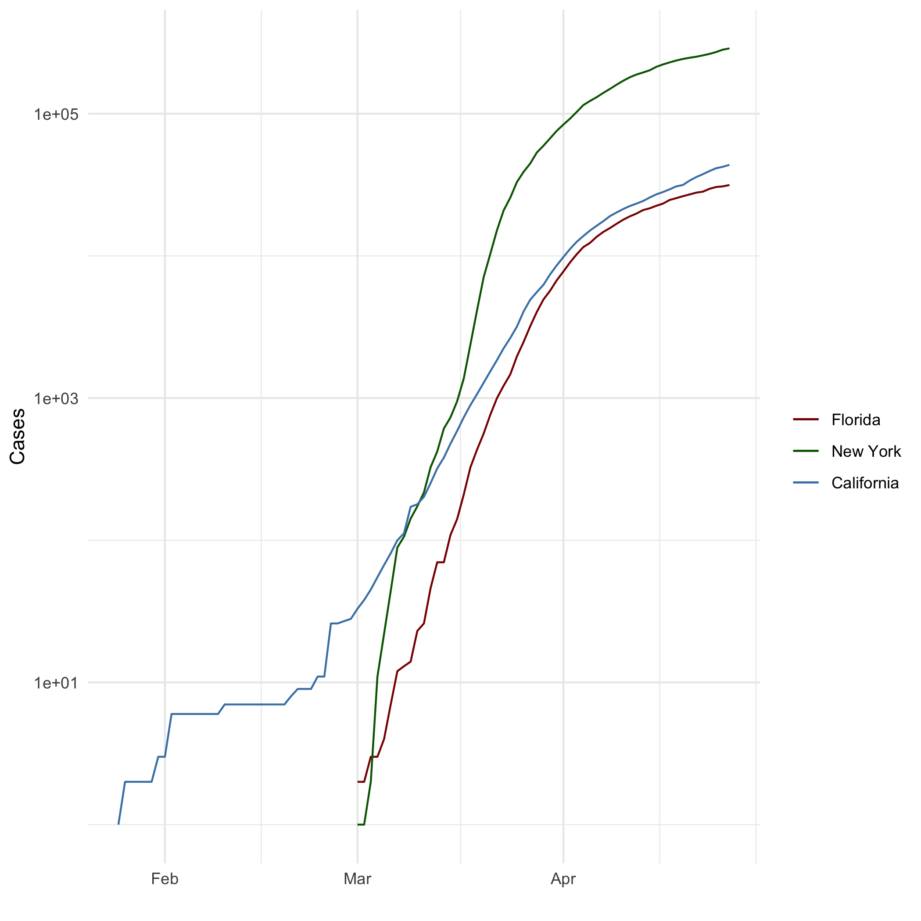

All Cases

## Add a Quote

“Success is not final, failure is not fatal: it is the courage to continue that counts” – Winston Churchill

## Add an Equation

1+1

## Add a Footnote

Here is a footnote.[1]

## Add Citations

* R for Everyone (Lander 2014).
* Discovering Statistics Using R (Field, Miles, and Field 2012).

# Inline Code

## NY Times COVID-19 Data

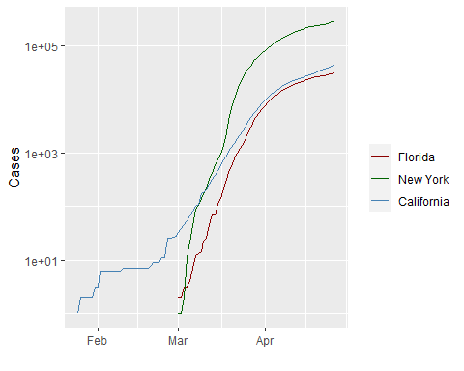

## R4DS Height vs Earnings

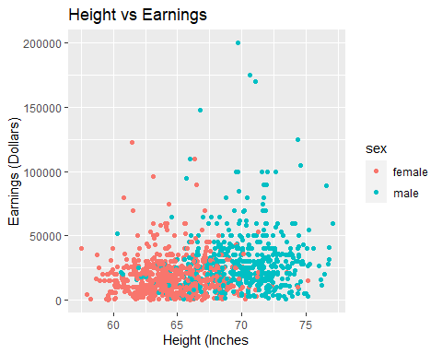

# Tables

name <- c("Aragon", "Bilbo", "Frodo", "Galadriel", "Sam", "Gandalf", "Legolas", "Sauron", "Gollum")  
race <- c("Men", "Hobbit", "Hobbit", "Elf", "Hobbit", "Maia", "Elf", "Maia", "Hobbit")  
in_fellowship <- c(TRUE, FALSE, TRUE, FALSE, TRUE, TRUE, TRUE, FALSE, FALSE)  
ring_bearer <- c(FALSE, TRUE, TRUE, FALSE, TRUE, TRUE, FALSE, TRUE, TRUE)  
age <- c(88, 129, 51, 7000, 36, 2019, 2931, 7052, 589)  
  
characters_df <- data.frame(name, race, in_fellowship, ring_bearer, age)

## Knitr Table with Kable

library(knitr)  
knitr::kable(characters_df,col.names = c("Name","Race","In Fellowship?","Is Ring Bearer?","Age"), caption = "One Ring to Rule Them All.")

One Ring to Rule Them All.

| Name | Race | In Fellowship? | Is Ring Bearer? | Age |
| --- | --- | --- | --- | --- |
| Aragon | Men | TRUE | FALSE | 88 |
| Bilbo | Hobbit | FALSE | TRUE | 129 |
| Frodo | Hobbit | TRUE | TRUE | 51 |
| Galadriel | Elf | FALSE | FALSE | 7000 |
| Sam | Hobbit | TRUE | TRUE | 36 |
| Gandalf | Maia | TRUE | TRUE | 2019 |
| Legolas | Elf | TRUE | FALSE | 2931 |
| Sauron | Maia | FALSE | TRUE | 7052 |
| Gollum | Hobbit | FALSE | TRUE | 589 |

## Pandoc Table

##   
##   
## +-----------+--------+---------------+-------------+------+  
## | name | race | in_fellowship | ring_bearer | age |  
## +===========+========+===============+=============+======+  
## | Aragon | Men | TRUE | FALSE | 88 |  
## +-----------+--------+---------------+-------------+------+  
## | Bilbo | Hobbit | FALSE | TRUE | 129 |  
## +-----------+--------+---------------+-------------+------+  
## | Frodo | Hobbit | TRUE | TRUE | 51 |  
## +-----------+--------+---------------+-------------+------+  
## | Galadriel | Elf | FALSE | FALSE | 7000 |  
## +-----------+--------+---------------+-------------+------+  
## | Sam | Hobbit | TRUE | TRUE | 36 |  
## +-----------+--------+---------------+-------------+------+  
## | Gandalf | Maia | TRUE | TRUE | 2019 |  
## +-----------+--------+---------------+-------------+------+  
## | Legolas | Elf | TRUE | FALSE | 2931 |  
## +-----------+--------+---------------+-------------+------+  
## | Sauron | Maia | FALSE | TRUE | 7052 |  
## +-----------+--------+---------------+-------------+------+  
## | Gollum | Hobbit | FALSE | TRUE | 589 |  
## +-----------+--------+---------------+-------------+------+

# References

Field, A., J. Miles, and Z. Field. 2012. *Discovering Statistics Using r*. SAGE Publications. <https://books.google.com/books?id=wd2K2zC3swIC>.

Lander, J. P. 2014. *R for Everyone: Advanced Analytics and Graphics*. Addison-Wesley Data and Analytics Series. Addison-Wesley. <https://books.google.com/books?id=3eBVAgAAQBAJ>.

1. This is what a footnote looks like.